**Getting Started With Node Js**

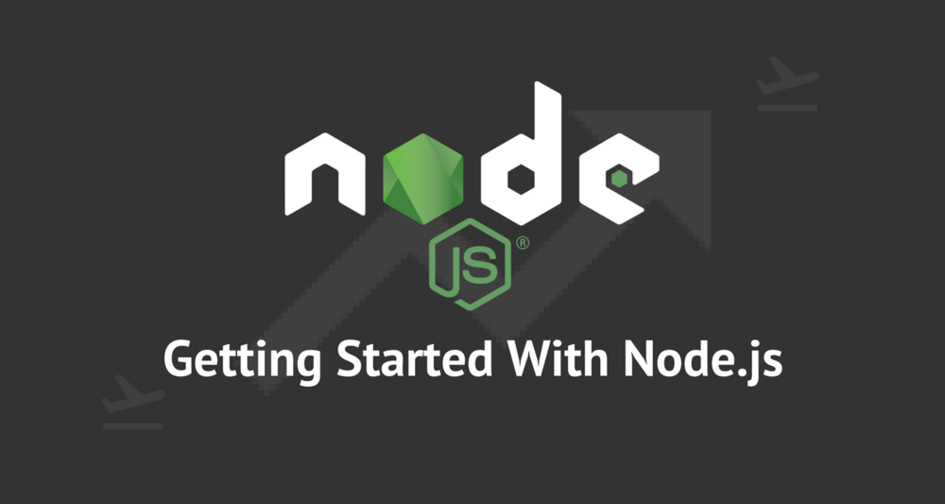

This article covers the following areas of NodeJS.

* Introduction of NodeJS
* Installation of NodeJS and NPM
* Node Package Module (NPM)
* Package.json
* Basic Example
* Express.js

**NodeJS**

NodeJS is an open-source, cross-platform runtime environment for developing server-side web applications. It is built on top of Google Chrome’s V8 Engine, which is a high performance Javascript engine written in C++. NodeJS also has an event-driven architecture capable of asynchronous I/O. It is single threaded. As an asynchronous event-driven JavaScript runtime, Node.js is designed to build scalable network applications. Users of Node.js are free from worries of dead-locking the process, since there are no locks. Almost no function in Node.js directly performs I/O, so the process never blocks. Because nothing blocks, scalable systems are very reasonable to develop in NodeJS.

*NodeJS uses an event-driven, non-blocking I/O model that makes it lightweight and efficient.*

**Installation of NodeJS and NPM**

Installation of NodeJS and NPM is straightforward using the installer package available at NodeJS official web site.

* Download the installer from [NodeJS WebSite](https://nodejs.org/en/)(<https://nodejs.org/en/>)
* Run the installer.
* Follow the installer steps, agree the license agreement and click the next button.
* Restart your system/machine.

Now, test NodeJS by printing its version using the following command in Command Prompt:

> node -v

and test npm by printing its version using command

> npm -v

Simple way to test nodeJS work in the system is to create a javascript file which print a message.

Lets create test.js file

/*test.js file*/

console.log("Node is working");

Run the test.js file using Node command **> node test.js** in command prompt.

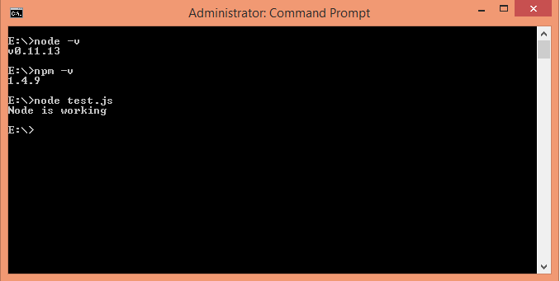

Installation is done.

**Node Package Module**

[NPM](https://www.npmjs.com/) is the package module which helps javascript developers load dependencies effectively. To load dependencies we just have to run a command in command prompt:

> npm install

This command is finding a json file named as **package.json** in root directory to install all dependencies defined in the file.

**Package.json**

[Package.json](https://docs.npmjs.com/files/package.json) looks like:

{

"name": "ApplicationName",

"version": "0.0.1",

"description": "Application Description",

"main": "server.js",

"scripts": {

"start": "node server.js"

},

"repository": {

"type": "git",

"url": "https://github.com/npm/npm.git"

},

"dependencies": {

"express": "~3.0.1",

"sequelize": "latest",

"q": "latest",

"tedious": "latest",

"angular": "latest",

"angular-ui-router": "~0.2.11",

"path": "latest",

"dat-gui": "latest"

}

}

The most important things in your package.json are name and version. Those are actually required, and your package won't install without them. The name and version together form an identifier that is assumed to be completely unique. Changes to the package should come along with changes to the version.

### Repository

{

"repository": {

"type": "git",

"url": "https://github.com/npm/npm.git"

}

}

Specify the place where your code lives. Through this repository, developers can reach out and contribute to your application. If the git repository is not GitHub, then the npm docs command will be able to find you.

### Scripts

{

"scripts": {

"start": "node server.js"

}

}

NPM provide many useful [Scripts](https://docs.npmjs.com/misc/scripts) like npm install, npm start, npm stop etc.

Some default script values are based on package contents.

"start": "node server.js"

If there is a server.js file in the root of your package, then npm will default the start command to node server.js.

We can create our own custom scripts, and run through npm..

### Dependencies

{

"dependencies": {

"express": "~3.0.1",

"sequelize":"latest",

"q":"latest",

"tedious":"latest",

"angular":"latest",

"angular-ui-router": "~0.2.11",

"path":"latest",

"dat-gui":"latest"

}

}

[Dependencies](https://docs.npmjs.com/files/package.json#dependencies) are specified in a simple object that maps a package name to a version range. Version Name must be Version exactly.

If you want to install the latest version of a file, you just have to put latest in place of the version name.

Tilde(~) is used to tell "Approximately equivalent to version".

**Basic Example**

Create a server.js javascript file with following code

/*server.js*/

const http = require('http');

const hostname = '127.0.0.1';

const port = 3000;

const server = http.createServer(function(req, res) {

res.statusCode = 200;

res.setHeader('Content-Type', 'text/plain');

res.end('Hello World\n');

});

server.listen(port, hostname, function() {

console.log('Server running at http://'+ hostname + ':' + port + '/');

});

As we need http to create an http server we use require('http') and pass it to a variable named http

var http = require('http');

We also need to defined hostname and port number, here we use localHost i.e 127.0.0.1 and port number 3000 and assign this to the variables hostname and port, respectively.

var hostname = '127.0.0.1';

var port = 3000;

Next we create the http server using the createServer method.

var server = http.createServer(function(req, res){

res.statusCode = 200;

res.setHeader('Content-Type', 'text/plain');

res.end('Hello World\n');

});

This created the server as well as a response having statusCode: 200, Content-Type header of plain text and and ends with the string Hello World. This is the response that the server can send to browser.

*the function has two parameters req and res which is the request from and response to the server, respectively.*

In our example we are creating responses.

We created the server, now we have to assign it a hostname and port number.

server.listen(port, hostname, function() {

console.log('Server running at http://'+ hostname + ':' + port + '/');

});

Here, the server listens to localhost on port 3000 and prints "Server running at <http://127.0.0.1:3000/>" in command prompt.

Now Run server.js file un node using command

> node server

Open a browser and enter url <http://127.0.0.1:3000/>. The browser will display **Hello World** message on the screen.

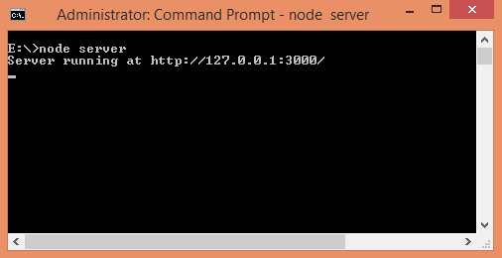

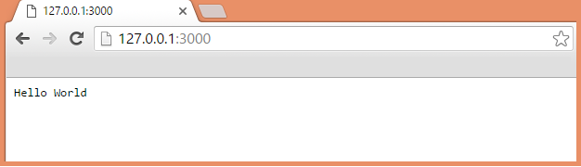

**Express.js**

Express.js, or simply Express, is a web application framework for Node.js, released as free and open-source software under the MIT License. It is designed for building web applications and APIs. It has been called the de facto standard server framework for Node.js.

Express is a minimal and flexible Node.js web application framework that provides a robust set of features to develop web and mobile applications.

It facilitates the rapid development of Node based Web applications. Following are some of the core features of Express framework −

* Allows to set up middlewares to respond to HTTP Requests.
* Defines a routing table which is used to perform different actions based on HTTP Method and URL.
* Allows to dynamically render HTML Pages based on passing arguments to templates.

.